FORNAX™ ePlanCheck Rule
Building Code Information
Rule ID | SWD 9.3.1
Rule Name | Minimum Radius of Drain Curve
Chapter | 9 Drainage Structures and Facilities
Section | 9.3 Curves and Bends
Handbook | Code of Practice on Surface Water Drainage  Seventh Edition – Dec 2018

Building Code Description
9.3 Curves and Bends

9.3.1 The presence of curves or bends in drain alignment is sometimes unavoidable. Difficulties in design often arise because of the complexity of the flow around a curved path. A drain curve will increase frictional loss and lead to the danger of serious local erosion due to spiral flow. Hence, the radius of any horizontal curve shall be as large as possible, consistent with the general terrain, in order to reduce the super elevation of the water surface and preserve the freeboard. A horizontal curve shall have a minimum radius of 3 times the width of the drain channel.

Rule Interpretation
- This rule checks for the minimum radius of the horizontal curve of a drain alignment.
- The minimum radius for horizontal drain curve shall be 3 times the width of the drain channel.
- The radius of the horizontal drain curve shall be measured from the inner curve of the drain channel.
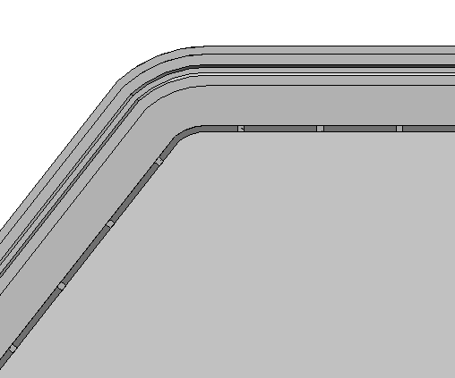
Drain Channel
W
Drain Curve

Boundary Fence
Radius of Drain Curve R≥ 3 x W

Minimum Radius of Drain - Plan View
FIGURE 01

Minimum
Radius of Drain Curve (R)
R≥ 3 x W
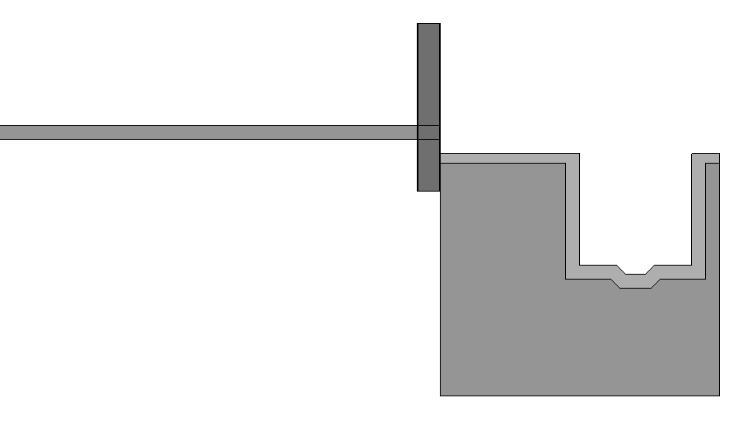
Boundary Fence
Storey 1
W
Width of Drain
Channel

Minimum Radius of Drain - Section View

FIGURE 02

Rule Scenario

Scenario 01 - Compliant
Requirement | The minimum radius of the horizontal drain curve is 3 times the width of the drain channel.
Description | A drain channel along the roadside has a width of 1200 mm. It has a drain curve radius equal to 3600 mm.
Drain Channel
Drain Curve
W = 1200 mm
Boundary Fence

``
Drain Curve Radius = 3600 mm

PLAN
FIGURE SCENARIO

Scenario 01 - Non-Compliant
Requirement | The radius of the horizontal drain curve is less than 3 times the width of the drain channel.
Description | A drain channel along the roadside has a width of 1200 mm. It has a drain curve radius equal to 3500 mm.
Drain Channel
Drain Curve
W = 1200 mm

Boundary Fence
Drain Curve Radius = 3500 mm

PLAN
FIGURE SCENARIO

Model PreCheck

Required Elements | Required Attributes
FlowFitting | IfcObjectType contains “Drain Channel Bend”
FlowSegment | IfcObjectType contains “Drain Channel”

Rule Parameters

Element Type 1
State | Type | Property | Operator | Value
Include | FlowFitting | IfcObjectType | Contains | Drain Channel Bend
Exclude |  |  | Match | N.A.
 |  |  | N.A. | <User defined>

Element Type 2
State | Type | Property | Operator | Value
Include | FlowSegment | IfcObjectType | Contains | Drain Channel
Exclude |  |  | Match | N.A.
 |  |  | N.A. | <User defined>

Element Type 1 Condition
* Minimum R is equal to | 3 | times W of Element Type 2

Result Messages
- 9.3.1 Minimum Radius of Drain Curve
  - Non-Compliant (TotalResultNumeric)
    - BuildingStorey (TotalResultPerFloorNumeric)
    - ElementType1 Value
    - Width: ResultNumeric mm; Radius: ResultNumeric mm
  - Compliant (TotalResultNumeric)
    - BuildingStorey (TotalResultPerFloorNumeric)
    - ElementType1 Value
    - Width: ResultNumeric mm; Radius: ResultNumeric mm
  - Attention (TotalResultNumeric)
    - BuildingStorey (TotalResultPerFloorNumeric)
    - ElementType1 Value is not provided.
    - ElementType2 Value is not provided.

Sample Result Messages
- 9.3.1 Minimum Radius of Drain Curve
  - Non-Compliant (1)
    - Storey 1 (1)
    - Drain Channel Bend
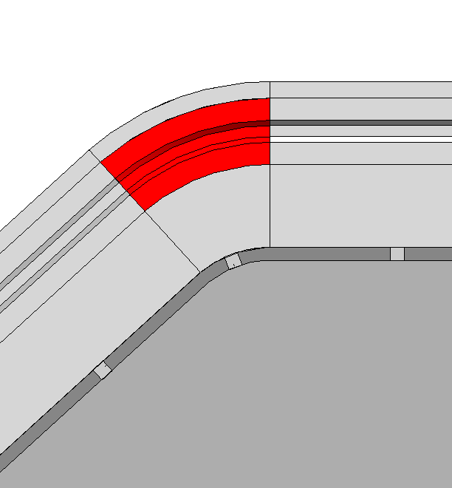
    - Width: 1200 mm; Radius: 3500 mm

3500mm

PLAN

  - Compliant (1)
    - Storey 1 (1)
    - Drain Channel Bend
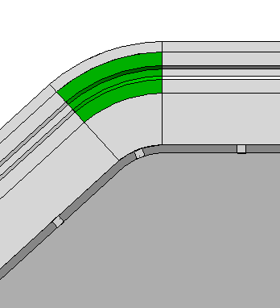
    - Width: 1200 mm; Radius: 3600 mm

3600mm

PLAN

  - Attention (2)
    - Storey 1 (2)
    - Drain Channel Bend is not provided.
    - Drain Channel is not provided.

Sample Result Model Views
- 9.3.1 Minimum Radius of Drain Curve
  - Non-Compliant
    - Plan view.
    - Highlight checked element/space.
    - Radial dimension of the element/space is displayed.
    - All other elements are translucent except the checked element/space.
  - Compliant
    - Plan view.
    - Highlight checked element/space.
    - Radial dimension of the element/space is displayed.
    - All other elements are translucent except the checked element/space.

Testing Scenarios
- Scenario 01 - Non-Compliant
- Storey 1
- A drain channel along the roadside has a width of 1200 mm. It has a drain curve radius equal to 3500 mm.

- Scenario 01 - Compliant
- Storey 1
- A drain channel along the roadside has a width of 1200 mm. It has a drain curve radius equal to 3600 mm.

Model:
SWD 9.3.1 Scenario 01 Non-Compliant.ifc
SWD 9.3.1 Scenario 01 Compliant.ifc

Modelling Guideline
- Specify IfcObjectType containing “Drain Channel Bend” for relevant FlowFitting.
- Specify IfcObjectType containing “Drain Channel” for relevant FlowSegment.

Specification Log
RA | Reymart C. Sisgon
Last edit date | 21 December 2018
ePC version
Updates | - V1

